**MIS 311 Week 5 Assignment**

**PE 4-3.** Consider the following user story in the context of a service that connects individual customers and individual service providers that complete household service tasks, such as picking up goods from a physical store, delivering prepared meals, monitoring a family’s house during a vacation, and so forth:

*As a service provider, I want to identify tasks that fit my interests and available time so that I can offer my services in a meaningful and profitable way*.

1. Identify at least three acceptance criteria that could be associated with this user story.

Whether or not the tasks fit the service provider’s interest. Do the available times work with that service provider? Does the scenario enable the service provider to effectively offer their services?

1. Illustrate the user story with a UI mock-up/mock-ups, including navigation guidance, if necessary.

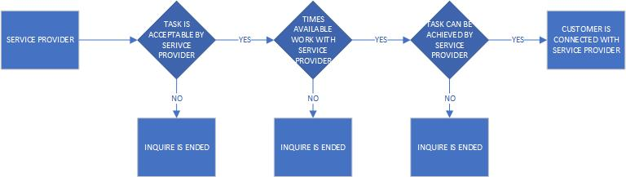

**PE 4-9.** Consider the following narrative (initially introduced in PE 2-9):

A financial services training provider, Finance for You and Me (FFYAM), offers thousands of two-to-six-day-long courses around North America. The courses take place mostly at hotels but sometimes also at conference centers or university campuses. In addition, FFYAM has an increasing number of online programs available. It is essential for FFYAM to understand and serve its customers’ needs as effectively as possible. Therefore, it is very important for the company to offer a smooth registration process, maintain a good quality-control system, and frequently reach out to its customers to understand what their training needs are.

Each of the courses has up to thirty students. (FFYAM wants to keep the numbers small to be able to offer a high-end alternative to low-cost online providers.) Currently, participants can sign up for a course online, but if they have any special requests, such as dietary restrictions, they need to call the company using its 1-800 number. A participant’s requests will need to be stored not only for the purposes of a particular course but also as part of the participant’s history with the company, to be used in the context of future courses. At times, an administrative assistant registers several participants from a company to the same course. In the case of more than ten participants in the same course, a company will get a volume discount.

After a course has been completed, the instructor will use the system to specify which participants completed the course successfully. Furthermore, FFYAM will invite each participant to respond to a quality-assurance survey. One follow-up invitation is also sent. Once the answer period has ended, a research analyst evaluates the data and creates a summary that will go to the instructor and FFYAM VP of Quality. In the case of particularly poor results, the VP will start an investigation.

1. Using the Word yellow highlighter, Identify all personas and user stories in the PE 4-9 case above. Write out at least one of the user stories you identified above.

As a customer who wants to take an online course with FFYAM I want to easily find the courses that will fit my needs the best.

1. Pick one of the user stories you identified and develop a wireframe that illustrates the key elements of the process the user will follow to achieve her/his goal(s) within the context of the user story. In addition to the wireframe, provide a narrative describing your reasoning for your choice of design.

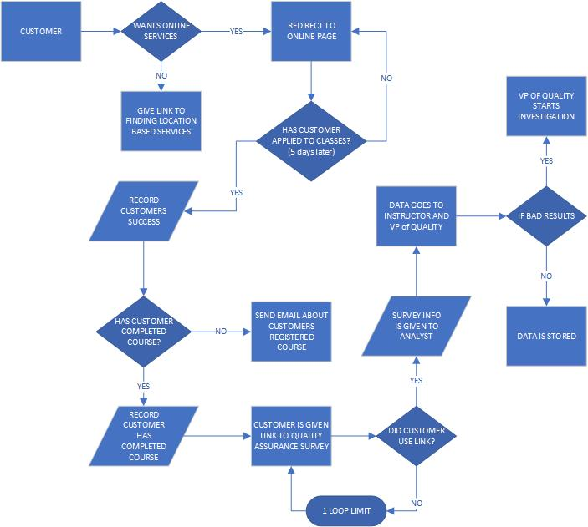

The start of the wireframe occurs when a customer visits the sites landing page. This will then jump into the wireframes first decision where the customer decides if they want online service or not. Since this wireframe is based on the user story the customer does want online service, so they go on through the path. There are several decisions that I put in that are not detailed in the case, but I thought were needs in order for user flow. After these it goes into the detailed information in the case where there needs to be checks on if a customer completed the course and then follow up with the survey. This is then followed up by the results of the survey if the results are bad or good and if bad then there is an investigation by the VP of quality.

1. Explain what you would do to this wireframe you created above to expand it to a mock-up by including the key controls and sample data. You can create a second drawing or just explain your process in words.

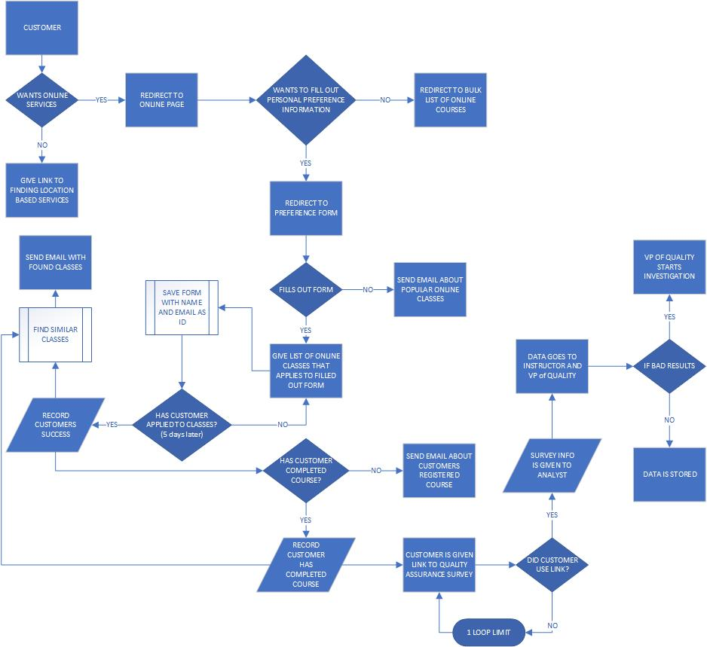

In this wireframe I took the same wireframe above, but I added some much needed decisions for the customer along with more information about what would likely happen on the website. Most notably is the form that the customer would most likely fill out in order to receive a better more personal list of classes. Then there are several data saves and subprocesses that would note the forms information and then the time at which the customer has or hasn’t registered for classes. This will enable emails to be sent to try and reengage with the customer. Then after this we have accouple data saves and process if the customer has completed a course at which they are given the same path as the previous wireframe, but they are also put on a emailing list that will send them more potential classes to take. Overall, there are much more checks in this wireframe to enable reengagement of the customer, which is just good marketing practices.

**PE 4-6.** Consider the following narrative:

*We Keep You On Time (WKYOT) is a small chain of about twenty watch-repair shops located in major metropolitan areas in the eastern part of the United States. WKYOT stores repair and restore both mechanical and electronic watches (excluding smart watches). WKYOT serves primarily individuals but it also has some commercial customers, and the company is interested in differentiating between these two types of customers. In most cases, a customer brings an item or a set of items to the shop for either a specific repair or a more comprehensive restoration.*

*During an initial conversation with a customer, a WKYOT expert evaluates the watch to be repaired and provides the customer with an estimate (separately for each item if there are multiple items). The expert also provides an estimated repair schedule. When a job is completed, a repair technician presents the watch for review by a store manager. If everything is OK, the manager sends a text message to the customer, letting him know that he can pick up the watch. The customer comes to the store to get the watch and pays for the work. A WKYOT expert asks the customer to review the results of the repair, and if the customer has comments, WKYOT wants to keep track of them. If the customer is not satisfied and the problem cannot be fixed immediately, WKYOT will have to initiate an emergency repair process*.

Identify and write at least one user story for each of the following personas in the context of this narrative:

1. Individual customer

As a customer I want to give my watch to WKYOT for them to repair in an agreed upon time and an agreed upon payment.

1. WKYOT expert

As an expert I need to be able to evaluate the watch presented to me and come up with a cost and time frame for the work.

1. Repair technician

As a repair technician I need to complete my work in the time frame presented and to the standards of the store manager.

1. Store manager

As a store manager I need to review all work that has been done on a watch and make sure that it is acceptable by the customer.

1. Pick two user stories, develop wireframes that illustrate the key elements of the process the user will follow to achieve her/his goal(s) within the context of the user story. Illustrate the key navigation options between the wireframes.

As a customer I want to give my watch to WKYOT for them to repair in an agreed upon time and an agreed upon payment.

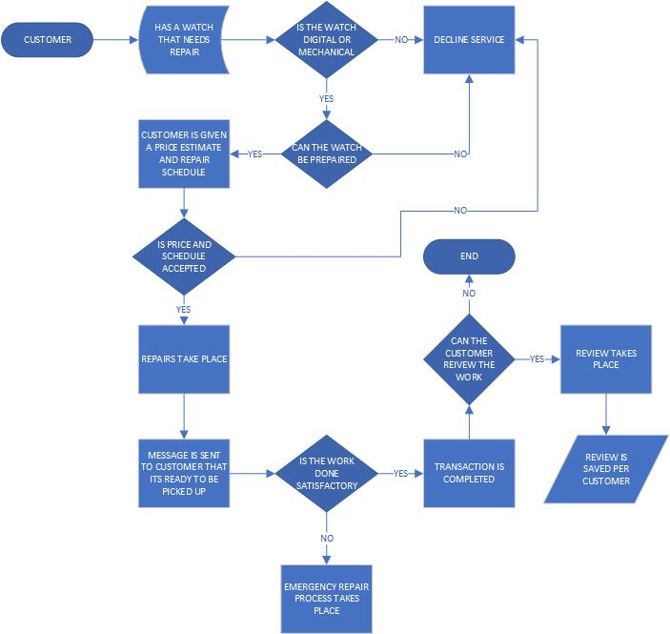

As an expert I need to be able to evaluate the watch presented to me and come up with a cost and time frame for the work.

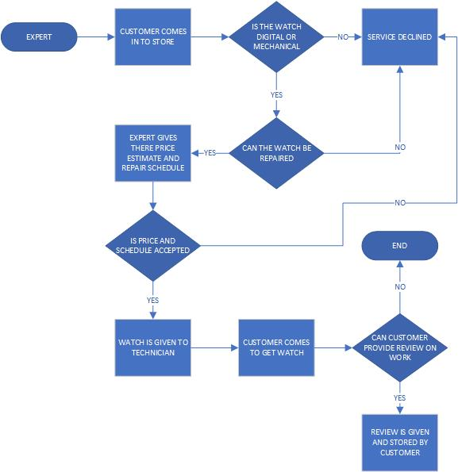

1. Select one wireframe that you have done in this assignment and expand it to a mock-up by including the key controls and sample data. Feel free to make up some data if the one you choose doesn’t enough information.

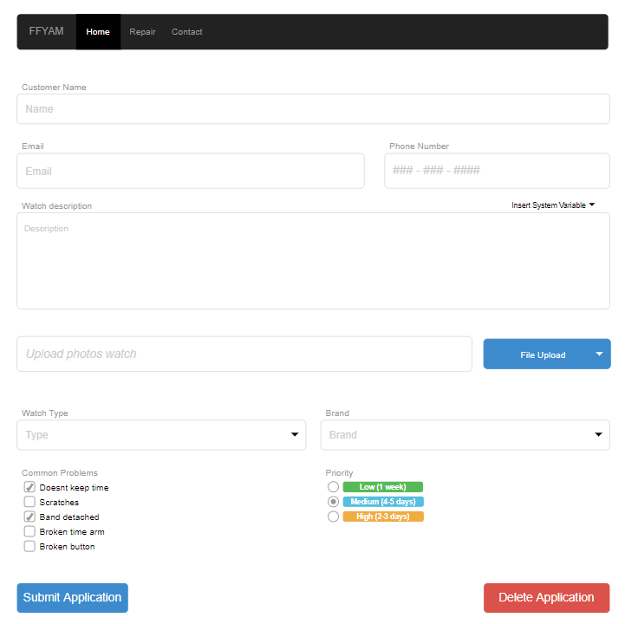

1. Based on what you learned through the process of developing the user stories and UI models, describe what changes you would recommend to the business process you developed in PE 4-6.

I think the bested way to increase user function would be to create a website that would enable customers to check what watches the business could repair before visiting the store. Also the website could have a mail in option where a customer would submit an application that included there watches with pictures to be checked by the expert online and then after request review the customer would be sent the shipping information along with information for packing and shipping and time line/price. Then the customer has the option to accept this and then send the watches to the business for repair. After the watches are repaired the customer is sent pictures and possibly a video of their watches. If the customer reviews this and says it is satisfactory then the watches are sent back to the customer.